
East West University
Department of Computer Science and Engineering

Course: CSE251 Electronic Circuits
Expt No.: 6
Title: Measurement of Parameters and I-V characteristics of an N-channel MOSFET

Objectives:
- To measure the threshold voltage V_{t} and the process transconductance K_{n} of an N-channel enhancement type MOSFET.
- To measure the I-V characteristics (I_{D} vs. V_{DS}) of an N-channel enhancement type MOSFET.

Circuit Diagram:
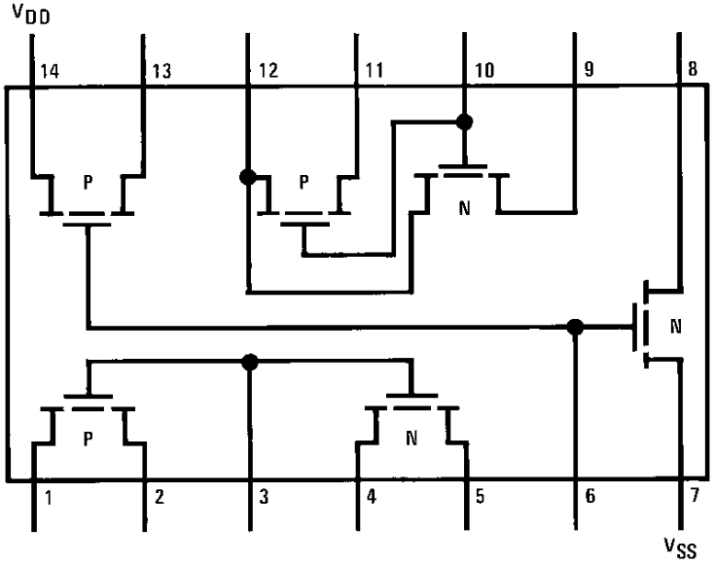
Figure 1. Pin diagram of CD4007C IC.

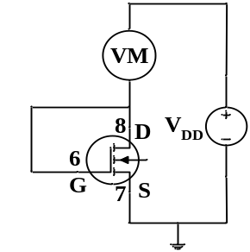
Figure 2. Circuit for measurement of V_{t} and K_{n} of an NMOSFET.
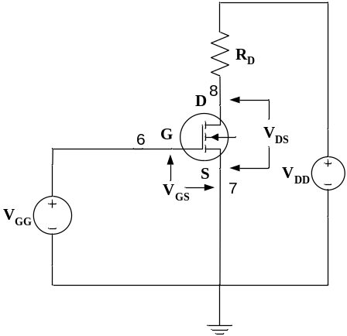
Figure 3. Circuit for measurement of I-V characteristics of an NMOSFET.

Equipments and Components Needed:
- Digital trainer board
- DC power supply
- Digital multimeter
- DC Voltmeter
- CD4007C IC (1 pc)
- Resistor (1KΩ 1 pc)
- Breadboard
- Connecting wires

Lab Procedure:
MEASUREMENT OF V_{t} AND K_{n}:
- Measure the resistance and connect the circuit as shown in Figure 2. Note that a voltmeter (VM) is in series with the drain and V_{DD}; and G and D are shorted. Use the pin numbers as shown in Figure 2.
- Set V_{DD} to 10V from the DC power supply unit and measure the reading of the voltmeter. The threshold voltage V_{t} = V_{DD} – VM reading.
- Now replace the voltmeter by 1KΩ resistance and measure the voltage drop across the resistance. Divide it by the resistance to get I_{D}. Measure V_{GS} and calculate the process transconductance from K_{n} = 2I_{D}/(V_{GS}-V_{t})².

MEASUREMENT OF I-V CHARACTERISTICS:
- Connect the circuit as shown in Figure 3 and set V_{GG} = V_{t}+1V from the trainer board variable power supply.
- Use the DC power supply unit as V_{DD}. Now change V_{DD} from 0 and measure V_{DS} and V_{RD} (voltage across R_{D} resistance). Calculate I_{D} from I_{D}=V_{RD}/R_{D}. Take around 15 data up to V_{DS} = 7V. Be careful so that V_{DD} does not exceed 15V.
- Set V_{GG} to V_{t}+2V and V_{t}+3V and repeat step 5.

- Have the datasheet signed by your instructor.

Post-Lab Report Questions:
- You have V_{t} and K_{n}. Note that here K_{n} is equivalent to K’_{n}(W/L) of the text. For three V_{GG} (V_{GG} = V_{GS}) values of Figure 3, use the linear (triode) and saturation current expressions to tabulate the I_{D} for each V_{DS} and plot the I_{D}-V_{DS} curves using your calculated and experimental data on the same graph. Use MATLAB for plotting.
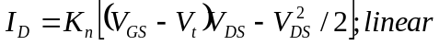
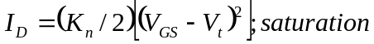
- Write your observation and comments on the calculated and experimental graphs, especially in the saturation regions.
- For V_{GG} = V_{t}+3V, take two experimental data points in saturation and calculate the slope. From the slope, obtain output resistance r_{o}.
- Simulate the circuit shown in Figure 3 using PSPICE. For simulation use MbreakN3 MOSFET and DC sweep analysis with nested loop for the three different values of V_{GG}. To set the parameters, double click on MbreakN3 and set W and L to 1E-6 (1um). Now select MbreakN3 (it will turn red) and go to Edit→Model→Edit Instance Model (Text). Delete everything in the appeared window and write the followings (put your values of V_{t} and K_{n}) and click OK.

.MODEL MbreakN3 NMOS
LEVEL = 3
VTO = 1.8
KP = 100E-6

